SYSTEM IDENTIFICATION
- PROJECT -

Teacher: Students:
Lucian Bușoniu Mihuț Larisa- Diana
Nenu Maria

Year of study: 3
Group: 30331

CONTENTS

- Introduction ..................................................................................................3

- Theoretical background ............................................................................... 3
2.1. Regression..............................................................................................3
2.2. ARX.......................................................................................................4

- PART 1: Fitting of an unknown function......................................................4
  - The set of data....................................................................................4
  - MATLAB solution.............................................................................5
  - Results................................................................................................5
  - Discussion..........................................................................................8
  - Appendices
    - A1: Main function .......................................................................9
    - A2: Function for calculating the regressors matrix.....................10
    - A3: Function for calculating the approximated matrix...............11
    - A4: Function for calculating the mean square error....................11

- PART 2: Nonlinear ARX identification........................................................11
  - The set of data....................................................................................11
  - MATLAB solution.............................................................................11
  - Results................................................................................................12
  - Discussion..........................................................................................16
  - Appendices.........................................................................................15
    - B1: Polynomial model function...................................................15
    - B2: Function for calculating the phi matrix.................................16
    - B3: Prediction Function...............................................................16
    - B4: Simulation Function..............................................................17
    - B5: MSE Function.......................................................................17
    - B6: Main Function.......................................................................18

- Introduction

This report represents the first and the second part of the assignment for the System Identification course. We are disscussing our solution for the problem of fitting an unknown function and for a nonlinear ARX identification. All code is written in MATLAB.

Main topics of the first part:

- Theoretical background: aspects about the technologies used
- Fitting an unknown function : computation of a configurable polynomial generator and of the model fitting of the function
- Conclusions and Results : disscusion on results, overfitting and model choice
- Appendix: source code written in MATLAB

Main topics of the second part:

- Theoretical background: aspects about the technologies used
- Nonlinear ARX ientification: computation of a black- box model for a system, using a polynomial, nonlinear ARX model
- Conclusions and Results: discussion on results, quality of the model fit on the given data sets
- Appendix: source code written in MATLAB

- Theoretical background

  - Regression
Regression models are static models that make correlations between two or more random variables for predicting one of them based on the others.
Linear regression is one of the main parts of statistics when it comes to predictions. Prediction represents the process of estimating an unknown value based on a given one and it consists of two parts:
- determination of the regression equation
- usage of the equation in a prediction

Non-linear regression appears when the link between the two static variables is not linear, but it exists. The dependent variable is a nonlinear combination of the independent variables.
The polynomial regression is going to have the following form:

Y = b₀+ b₁X+ b₂X²+...+b_{n}X^{n} , b_{0...n}- constants
Y- resultant variable
X- predictor variable
We suppose that our data satisfy the equations:

Y_{i} = b₀+ b₁X_{i}+ b₂ X_{i}² +...+b_{n} X_{i}^{n}

In matrix form the model takes the following form:

Y= X* b,

Where:

Y₁
Y = Y₂ , a p-dimensional vector (2.1.1)
....
Y_{p}

1 X₁ ... (X₁)^{n}
X= ... ... ... ... , marix of the regressors (basis functions) (2.1.1)
1 X_{p} ... (X_{p})^{n}

b- (n+1) vector, its components are the constant/unknown values of the model

b= (X’ * X)⁻¹ * X’ * Y . (2.1.3)

  - ARX (AutoRegressive eXogenous)

The ARX method produces polynomial parametric models. The ARX method is recurssive, the current output y(k) is computed based on the previous input and output.

y(k) = −a₁y(k − 1) − a₂y(k − 2) − . . . − a_{na}y(k − na) b₁u(k − 1) + b₂u(k − 2) + . . . + b_{nb}u(k − nb) + e(k),
(2.2.1)
Where:

e(k) - the noise from k,
a₁, a₂, . . . , a_{na} and b₁, b₂, . . . , b_{nb} – parameters of the model

The compact form of the ARX model is:

A(q ⁻¹ )y(k) = B(q ⁻¹ )u(k) + e(k) (2.2.2)

- PART 1: Fitting of an unknown function

In this part we create in MATLAB a model for a configurable polynomial function that is nonlinear and static, with the help of regression.

  - The set of data

We are given 2 sets of data, one for identification (id) and one for validation (val). Each one has a set of grid coordinates:
- X for the inputs, a cell array of 2 vectors: X{1}(i), X{2}(i);

- Y for the ouputs(corrupted by noise, additive, zero-mean Gaussian), a matrix (n x n), where Y(i,j) = f(X{1}(i) , X{2}(j)), (see 2.1.1)
where f- unknown, linear, static function;

  - MATLAB solution

Brief explanation of the functions used to calculate the solution:
- The function for calculating the regressors matrix returns the regressors depending of the choosen degree, after the computation of the polynomial. The output of this function is represented by the “fi” matrix. The accuracy of our model depends on this function. (Appendix A2)
- The function for calculating the approximated matrix calculates first the matrix of the unknown constants of the polynomial. Therefore it returns the approximated matrix. (Appendix A3)
- The Mean Square error function returns the error of the algorithm. (Appendix A4).
- The Main function uses all the function mentioned above in order to plot the desired figures.(Appendix A1)

  - Results

The plot of the identification data is presented below (see Figure 1).

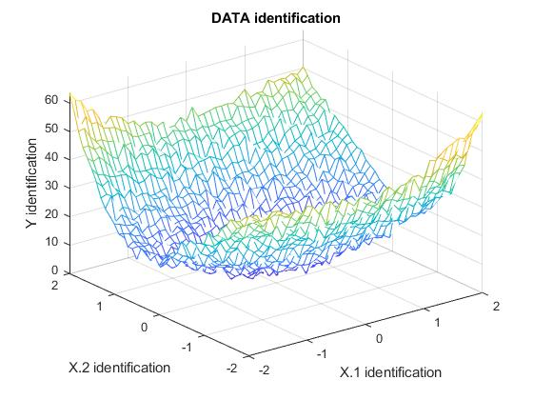
Figure 1 Plot of the identification data

In order to obtain best results, we computed polynomials for different degrees for the identification data set (Figure 2) and the validation data set (Figure 3).
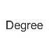
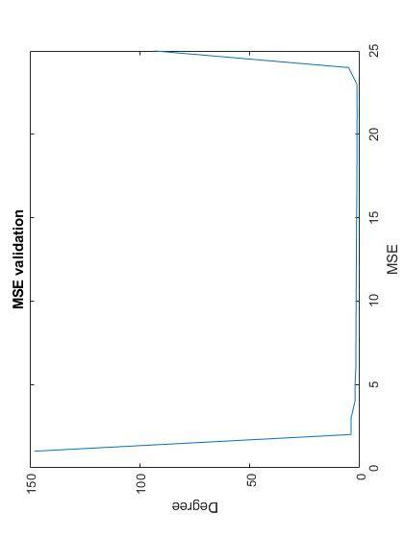
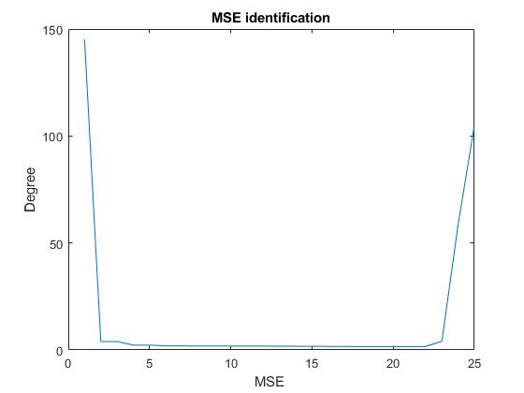

Figure 2. Mean square error for the identification data set

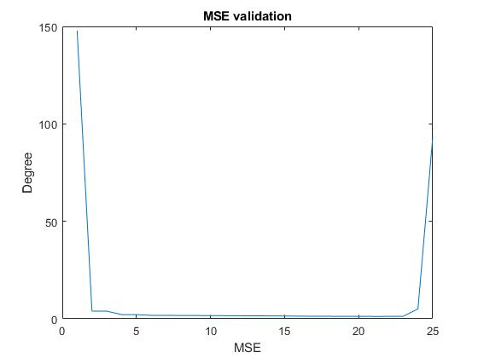

Figure 3. Mean square error for the validation data set

The following table contains the values obtained for the MSE for the indentificaton and validation datasets:

Degree of the polynomial | MSE for identification | MSE for validation
1 | 145.2486 | 147.8117
2 | 3.9381 | 3.9297
3 | 3.9366 | 3.9280
4 | 2.2693 | 2.1526
5 | 2.2595 | 2.1299
6 | 1.9099 | 1.7626
7 | 1.8956 | 1.7465
8 | 1.8569 | 1.7033
9 | 1.8448 | 1.6716
10 | 1.8297 | 1.6612
11 | 1.8124 | 1.6967
12 | 1.7843 | 1.5618
13 | 1.7549 | 1.5314
14 | 1.7250 | 1.4901
15 | 1.6921 | 1.4365
16 | 1.6583 | 1.3519
17 | 1.6269 | 1.3130
18 | 1.5987 | 1.2885
19 | 1.5907 | 1.2635
20 | 1.5946 | 1.2573
21 | 1.5820 | 1.2259
22 | 1.6076 | 1.2317
23 | 4.1087 | 1.2608
24 | 58.7355 | 5.0163
25 | 104.9609 | 93.2884

The MSE for degree 21 has the smallest value, so for degree 21 our model fits the best the validation plot. We have used color red for the validation data and green for the model. (See figure 4)
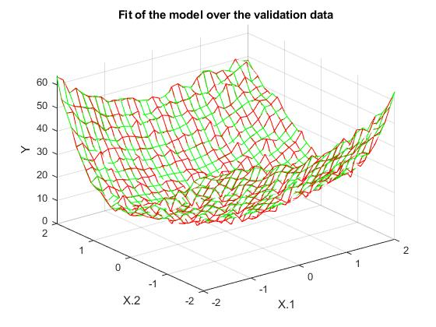

Figure 4. Plot for validation and for the model

  - Disscussion

We can see that the MSE becomes smaller as the degree increases. The more degrees we have, the fitting of the polynomial on the set is better, but as the best fitting is achived for a certain degree a common problem occurs. This problem is known as overfitting, when algorithms can predict unreal and impossible situations because of the experience on the test set. As a result, complexity often makes the prediction poor, it describes more the noise instead of the system itself.
Also, in our case, the sampled data lies between [-2,2], so the values are extreamly close one to each other. When we try to compute polynomials, we encounter rank deficency problems that affects the condition of the model.

  - Appendices

    - A1: Main function
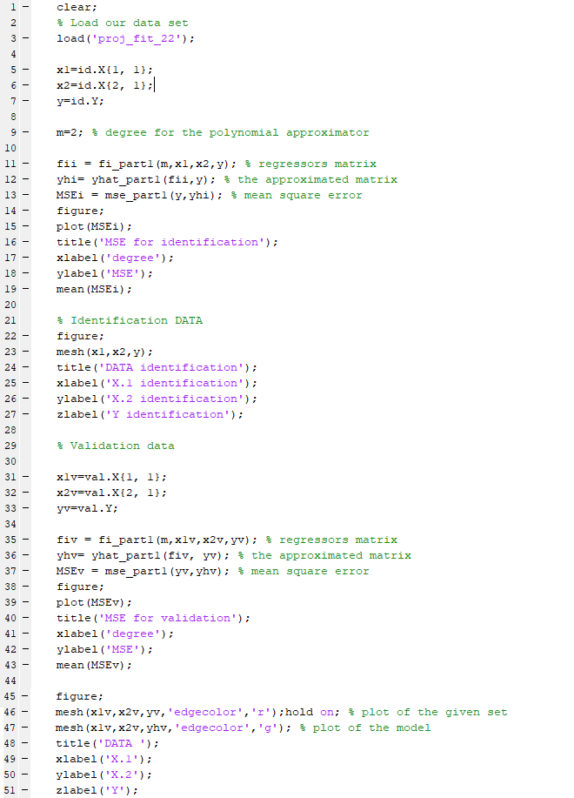

    - A2: Function for calculating the regressors matrix
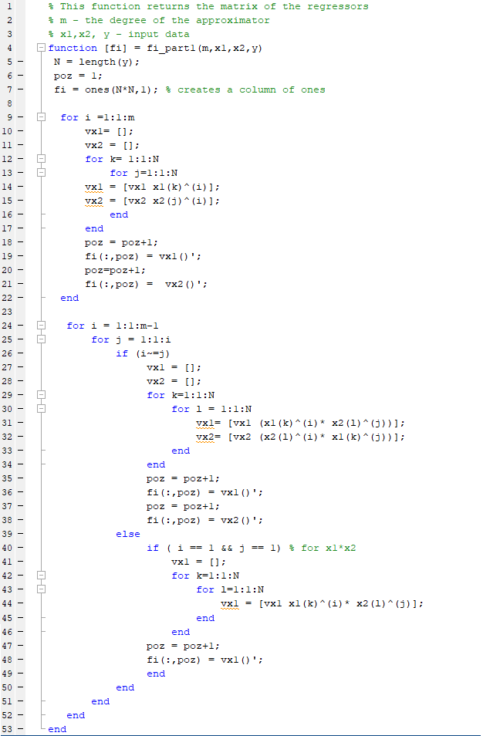

    - A3: Function for calculating the approximated matrix
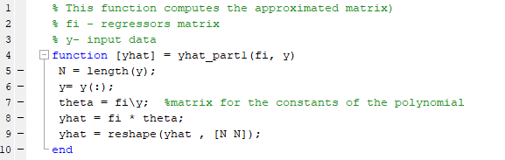

    - A4: Function for calculating the mean square error

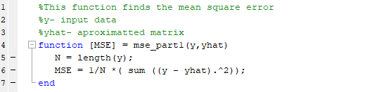

- Nonlinear ARX identification

In this part we create an ARX model generator for configurable orders na, nb, delay nk, an polynomial degree m. We also code the linear regression procedure. The model can be used in two modes: one- step- ahead prediction (uses knowledge of the real delayed otputs of the system) and simulation (knowledge about the real otputs is not available).

  - The set of data

We are given 2 data sets, with variables id and val. Those datasets are measured on an unknown dynamic system with one input and one output.

  - MATLAB solution

Brief explanation of the functions used to calculate the solution:

- The function for calculating the polynomial model returns every line of the phi matrix. The accuracy of our model depends on this function. (Appendix B1 )
- The function for calculating the phi takes every line consisting of polynomials that coresponds to every output value and build the final phi matrix. (Appendix B2)
- The function for prediction returns the model when we know the real delayed outputs of the system. (Appendix B3)
- The function for simulation returns the model when we use previous otputs of the model itself. (Appendix B4)
- The Mean Square error function returns the error of the algorithm. (Appendix B5).
- The Main function uses all the function mentioned above in order to plot the desired figures.(Appendix B6)

  - Results

The plot of the identification data is presented below (see Figure 5).
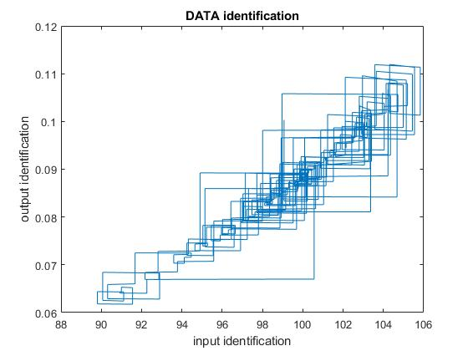
Figure 5. Plot of the identification data

In order to obtain best results, we computed polynomials for different degrees, na, nb and delay nk. The mean square error of the predicted and simulated systems are presented in the following table. We took na == nb for reducing space search.

Degree of the polynomial | na | nb | nk | IDENTIFICATION |  | VALIDATION
 |  |  |  | MSE for prediction | MSE for simulation | MSE for prediction | MSE for simulation
1 | 1 | 1 | 1 | 4.6948*10⁻⁷ | 0.0054 | 2.4588*10⁻⁶ | 0.0066
1 | 2 | 2 | 1 | 4.4079*10⁻¹⁰ | 0.0071 | 3.2224*10⁻⁰⁷ | 0.008
1 | 3 | 3 | 1 | 6.3983*10⁻¹¹ | 0.0072 | 1.1990*10⁻⁰⁵ | 0.0083
1 | 4 | 4 | 1 | 4.2314*10⁻¹¹ | 0.0078 | 1.7878*10⁻⁰⁴ | 0.0113
1 | 5 | 5 | 1 | 2.9737*10⁻¹² | 0.0846 | 3.2778*10⁻⁰³ | 0.1309
1 | 1 | 1 | 2 | 9.5420*10⁻⁰⁷ | 0.008 | 2.7492*10⁻⁰⁶ | 0.0094
1 | 2 | 2 | 2 | 1.4734*10⁻⁰⁸ | 0.0073 | 2.2324*10⁻⁰⁷ | 0.0084
1 | 3 | 3 | 2 | 1.4246*10⁻⁰⁸ | 0.0081 | 1.5531*10⁻⁰⁵ | 0.0082
1 | 4 | 4 | 2 | 1.4122*10⁻⁰⁸ | 0.0494 | 4.6108*10⁻⁰⁴ | 0.0557
1 | 5 | 5 | 2 | 1.4226*10⁻⁰⁷ | 0.8222 | 2.025*10⁻⁰⁴ | 1.0878
2  2 | 1 | 1 | 1 | 2.2574*10⁻⁰⁷ | 0.0047 | 7.6787*10⁻⁰⁷ | 0.0054
2  2 | 2 | 2 | 1 | 1.3985*10⁻¹⁰ | 0.006 | 2.3353*10⁻⁰⁷ | 0.0068
2  2 | 3 | 3 | 1 | 6.1199*10⁻¹¹ | 0.0074 | 1.1818*10⁻⁰⁵ | 0.0081
2  2 | 4 | 4 | 1 | 4.1473*10⁻¹¹ | 0.007 | 3.4144*10⁻⁰⁴ | 0.0095
2  2 | 5 | 5 | 1 | 2.8662*10⁻¹¹ | 0.0659 | 1.6771*10⁻⁰⁴ | 0.104
2  2 | 1 | 1 | 2 | 1.8069*10⁻⁰⁷ | 0.0067 | 8.6933*10⁻⁰⁷ | 0.0078
2  2 | 2 | 2 | 2 | 1.4496*10⁻⁰⁸ | 0.0061 | 1.408*10⁻⁰⁷ | 0.007
2  2 | 3 | 3 | 2 | 1.4245*10⁻⁰⁸ | 0.0083 | 7.9991*10⁻⁰⁶ | 0.0082
2  2 | 4 | 4 | 2 | 1.412*10⁻⁰⁸ | 0.0627 | 3.562*10⁻⁰⁴ | 0.727
2  2 | 5 | 5 | 2 | 1.4227*10⁻⁰⁹ | 0.9038 | 1.8962*10⁰⁴ | 1.2106
3 | 1 | 1 | 1 | 2.1798*10⁻⁰⁷ | 0.0119 | 1.2309*10⁻⁰⁶ | 0.0123
3 | 2 | 2 | 1 | 1.4538*10⁻¹⁰ | 0.006 | 1.427*10⁻⁰⁷ | 0.0069
3 | 3 | 3 | 1 | 6.1304*10⁻¹¹ | 0.0071 | 9.3532*10⁻⁰⁷ | 0.0082
3 | 4 | 4 | 1 | 4.1562*10⁻¹¹ | 0.0261 | 0.0011 | 0.0405
3 | 5 | 5 | 1 | 2.8893*10⁻¹¹ | 0.945 | 9.8855*10⁻⁰⁵ | 0.1457
3 | 6 | 6 | 1 | 5.033*10⁻⁰⁶ | 0.0013 | 3.7516*10⁻⁰⁴ | 0.0027
3 | 1 | 1 | 2 | 1.6699*10⁻⁰⁷ | 0.0126 | 1.2854*10⁻⁰⁶ | 0.0141
3 | 2 | 2 | 2 | 1.4498*10⁻⁻⁸ | 0.0063 | 1.4234*10⁻⁰⁷ | 0.0073
3 | 3 | 3 | 2 | 1.4238*10⁻⁰⁸ | 0.0078 | 9.1389*10⁻⁰⁶ | 0.0085
3 | 4 | 4 | 2 | 1.4108*10⁻⁰⁸ | 0.389 | 4.4155*10⁻⁰⁵ | 0.5781
3 | 5 | 5 | 2 | 1.4226*10⁻⁰⁹ | 0.8361 | 1.395*10⁻⁰⁵ | 1.1031

For degree m= 2, na=nb= 2, delay = 1 we obtained best fit for the simulation methode. For degree m= 3, na= nb= 6, nk =1 we obtained best fit for the prediction method.
The following figures represent the plot on the training set for simulation (see Figure 6) and prediction (see Figure 7) and the plot for the validation set for simulation (see Figure 8) and prediction (see Figure 9) for the best fit values.

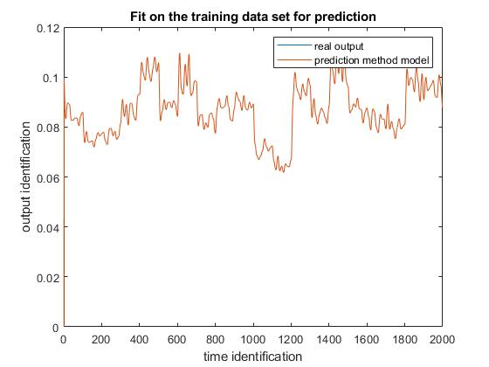
Figure 6. Fit on the training set for prediction method

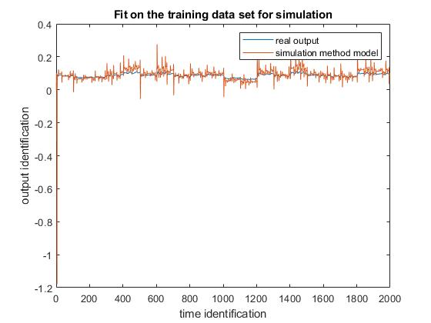
Figure 7. Fit on the training set for simulation method

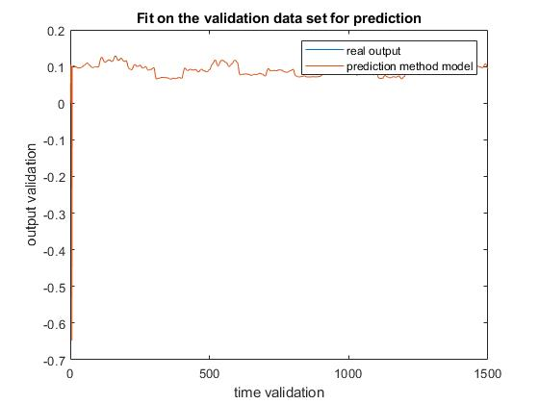
Figure 8. Fit on the validation data set for prediction method

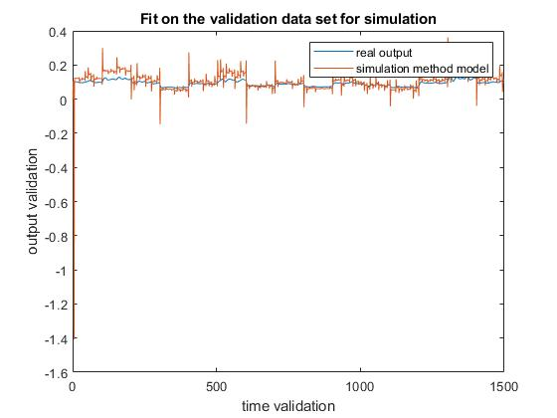
Figure 9. Fit on the validation data set for simulation method

  - Discussion

We can observe that for the prediction method the model has almost perfect fit from the beginning, while for the simulation method we get better and better fit by incresing the values for m, na, nb. This is because we have to use previously simulated values. But again, the overfitting problem will occur if using too many parameters.
As we increas the values for na,nb,m our polynomial becomes larger and the time for computation increases a lot.

  - Appendices

    - B1: Polynomial model function
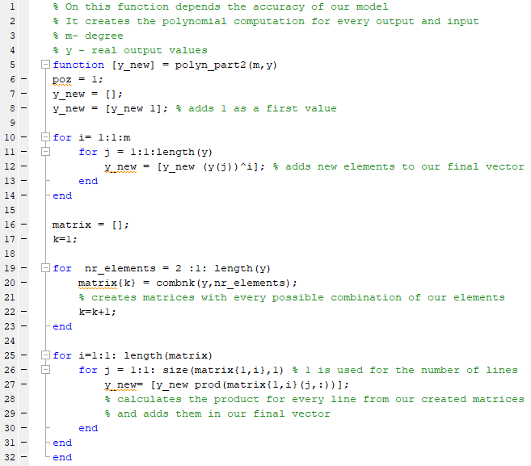

    - B2: Function for calculating the phi matrix

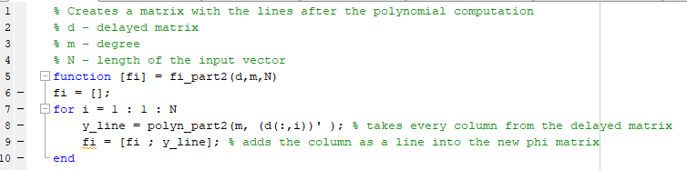

    - B3: Prediction function

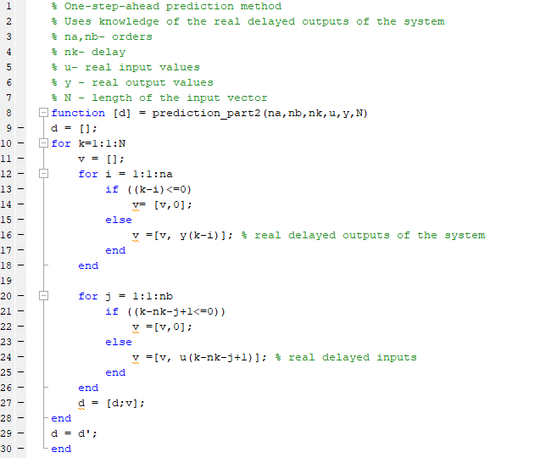

    - B4: Simulation function

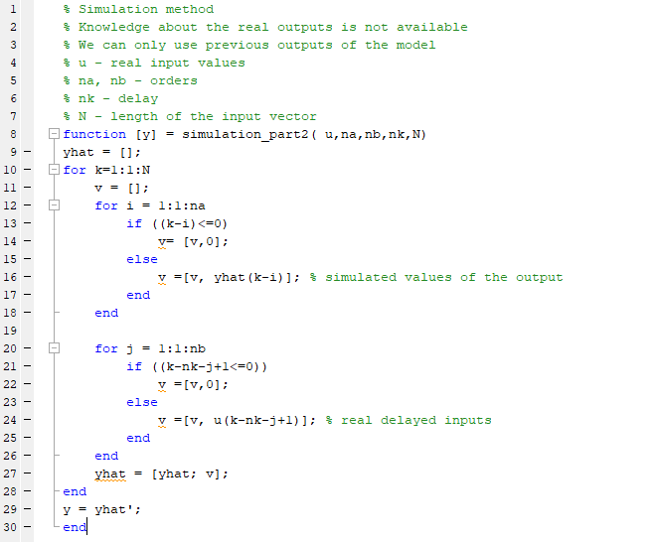

    - B5: MSE function

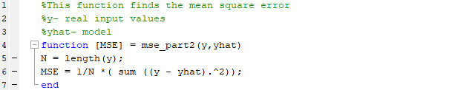
    - B6: The main function

